School of Engineering – “GRANDE ECOLE D’INGENIEURS”
Supported by the Chamber of Commerce and Industry of Rouen
FRANCE

APPLICATION FORM

MASTER PROGRAM

ACADEMIC YEAR 2017 / 2018

□ MSc. Management of Electronic and Embedded Systems (MSEE)

Session: ........................................

Surname: …………………………………………..
Photograph

First name: ……….…………………………….……

Country: ………...…………………………….......

Please return this application form by post to:

ESIGELEC-office in china
99,lai ting bei Road 181-302 a shanghai

or by email at: ying.liu@esigelec.fr
PERSONAL INFORMATION (to be completed by the applicant)
Surname: ……………………………........  Date of birth: ……………………………...  Sex: ............Nationality:………………....  Current address:  …………….……………………………….  ……………………………………………..  .................…………………………………  ………………………................................  Tel.: ……………………………………….  E-Mail 1:…………………………………... | First name(s): …………………………………..  City of birth: ………………………….………....  Country of birth:...............................................  Permanent address (if different from current address): ..........................................................................  ..........................................................................  ..........................................................................  ..........................................................................  Mobile:…………………………………………….  Email 2.:...........................................................
LANGUAGES (to be completed by the applicant)
Mother tongue: ……………………………………………………………………………………
Language of instruction (if different from mother tongue): .............................................................
Languages | I am currently studying this language |  | I have sufficient knowledge to follow lectures |  | I plan to take some lessons before departure for France
 | Yes | No | Yes | No | Yes | No
English  French | □  □ | □  □ | □  □ | □  □ | □  □ | □  □
BACKGROUND (to be completed by the applicant)
What is your current occupation (student, worker...):..........................………………………
Total number of higher education study years prior to departure abroad: ..........................
Complete name of the highest degree you will have before departure to France?
............................................................................................................................................
Name and city of the last university/school in which you have got (will get) this degree?
.............................................................................................................................................
Do you already have a work experience? □ Yes □ No
If yes, what was (is) your title?..............................................................................
If yes, what was (is) your domain of activity? .......................................................
Did you already go abroad? □ Yes □ No
If yes, when and where?.......................................................................................
If yes, what was the purpose of your journey?.....................................................
……………………………………………………………………………………….......
FIRST CONTACT WITH ESIGELEC (to be completed by the applicant)
How have you heard about ESIGELEC?
□ an ESIGELEC’s representative office abroad:
□ an old student from ESIGELEC:
□ a fair:
□ internet:
□ other (to be precised)

DOCUMENTS TO BE SENT BY THE APPLICANT WITH THE APPLICATION FORM
- Personal Resume (your motivations for choosing FRANCE and ESIGELEC, your professional project, your major strengths and weaknesses, your personal interests, your academic and professional experience)
- Curriculum Vitae
- Copy of the birth certificate (if possible)
- Copy of all academic transcripts (high school/university) for the past 4 years
- Copy of the obtained degrees/diplomas
- Copy of an official test in English Language: IAELTS or TOEIC or TOEFL or GRE
(if possible)
- Copy of the passport or ID card
- 1 letter of recommendation

RESERVED SPACE FOR ADMINISTRATION OF ESIGELEC
Réception du dossier par: ....................................................................le:……………………
Origine du dossier:…………………………………………………………………………………
Vérification du contenu du dossier par :...............................................le:……………………
Eléments manquants :……………………………………………..réception:.………….
……………………………………………...réception:……….…
……………………………………………...réception:……….…
……………………………………………...réception:……….…
Appréciation du dossier :
Nom de l’examinateur du dossier:..............................................................................
Fonction de l’examinateur du dossier:…………………………………………………...
Décision de l’examinateur du dossier:……………………………………………………
………………………………………………………………………………………………..
………………………………………………………………………………………………..
Signature de l’examinateur du dossier :
Date de l’examen du dossier :…………………….

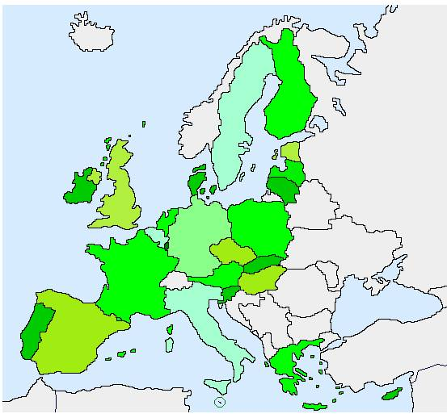

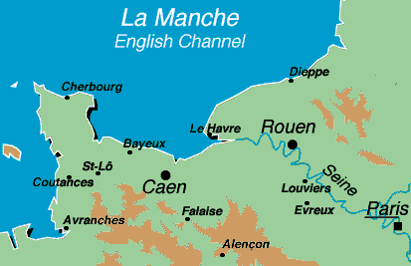

FRANCE

Normandy

ESIGELEC ROUEN
www.esigelec.fr

